Health Infrastructure Queensland

Response forms
Registration of Interest No.: HIQ1646
Project: Princess Alexandra Hospital
Services: Artist – Multiple Artwork Opportunities
Supplier: [Supplier to insert supplier name]
Issue date: Wednesday, 21 October 2026
Closing time and date: 2.00pm, Wednesday, 11 November 2026 (AEST)

Contents
1 Registration of interest project information 3
1.1 Project context 3
1.2 Artwork opportunity 3
1.3 Artwork format 4
1.4 Who can apply 4
1.5 Evaluation criteria 4
1.6 Selection process 4
1.7 What you need to submit 5
1.8 How to submit your registration of interest 6
1.9 Information session 6
Response Form 1 Supplier information 7
Response Form 2 Mandatory requirements 9
Response Form 3 Requirements 10
Supplier execution of a registration of interest 13

- Registration of interest project information
Health Infrastructure Queensland (HIQ) and Metro South Health (MSH) are inviting artists to register their interest in the process for artworks to feature in Princess Alexandra Hospital expansion project.
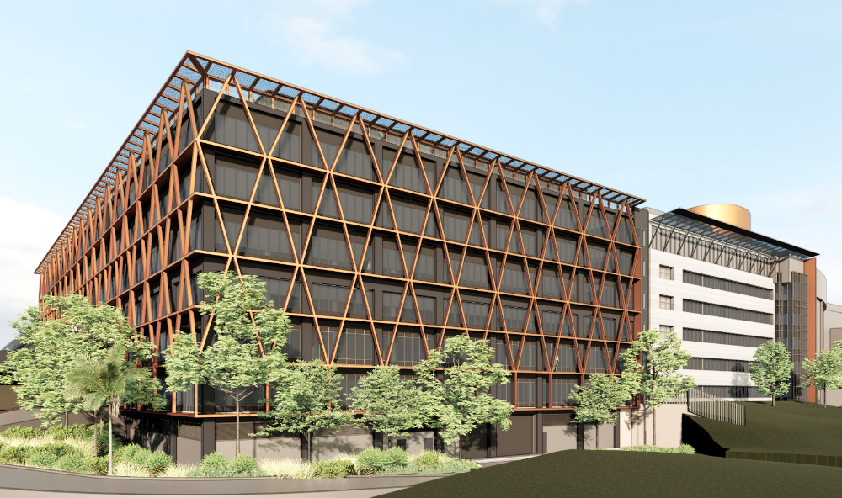
  - Project context
The Princess Alexandra Hospital (PAH) expansion is prioritising our upgrades to make sure we continue to provide high-quality care to our growing diverse communities.
Artworks chosen for inclusion within its environments should reflect clear consumer informed themes that align to the MSH vision and strategic and equity outcomes.
Using a co-design approach with our First Nations and diverse consumer partners, artwork can honour the legacies and histories of the past, create culturally safe and welcoming spaces, and support patient, staff and community wellbeing through creativity and storytelling.
While clinicians will always remain the experts in diagnosis and treatment, through the careful curation of artwork, we can further extend positive perceptions of the health service and the people who deliver care within it. To do this we support opportunities for quiet reflection, visual interest and inspiration for people receiving and delivering care.
  - Artwork opportunity
Artwork will be featured in a range of locations throughout the new facility including arrival areas, medical ward, intensive care unit, and waiting areas, interview rooms, hallways and corridors, staff zones, including potential opportunities for:
- large format vinyl wall coverings | - framed, hanging artwork pieces
- applications to reception desks | - painted murals direct to wall
- smaller scale printed decals | - digital works and projections.
  - Artwork format
Artwork formats and media will vary depending on location. Some artwork designs may need to be delivered in a high-resolution digital file suitable for printing/manufacture/installation.
  - Who can apply
Artists and collectives with a demonstrable connection to the PAH are welcome to register their interest. PAH is a statewide service, providing care to patients from many regions, so artists who have lived experience of the health service, or whose family and friends have lived experience, are particularly encouraged to register.

Queensland Health staff are not eligible to register for this opportunity due to potential conflict of interest issues.
  - Evaluation criteria
    - Connection to the health service
- Artists should be able to demonstrate a connection to the health service. This can include lived experience, strong family ties, previous or current residence in the surrounding suburbs, cultural links to Country or Traditional Owners.
- Artists are asked to briefly explain their connection in their submission.
    - Relevant experience
- Experience working on building-related art projects and in team settings.
- Must provide examples of previous work in digital format.
    - Availability
- Shortlisted artists must be ready to begin concept designs early in 2027.
- Selected artists will be required to commence detailed designs soon after being notified.
  - Selection process

Stage 1: Registration of interest
- Artists submit their applications. No concepts are required at this stage and should not be supplied.
- Applications are evaluated for inclusion on an eligible artist register for future artwork opportunities.

Stage 2: Shortlisting
Inclusion on the eligible artist register does not guarantee invitation to participate in future request for quotes.
When artwork opportunities arise, a shortlisting process will be undertaken to identify the artists most suited to the specific commission. In determining a shortlist, the following factors may be considered including:
- Relevance to specific commission objectives.
  - Alignment of the artist's medium and portfolio with the artwork opportunity.
  - Alignment with cultural and community considerations.
- Relevant artistic medium and technical approach with the commission.
- Relevant previous experience to the proposed commission.

Stage 3: Request for quote
Artists from the eligible list will be shortlisted and invited to submit an Offer for specific commissions that relate to their field of expertise.

1: Preliminary design concepts
- Shortlisted artists will be invited via a request for quote and asked to provide initial concept idea/s based on themes outlined in an artist brief.
- Shortlisted artists will receive a fee to support the creation of their initial concept/s.
- Concepts will be reviewed and preferred artists selected.

2: Detailed design
- Selected artists will be contracted and will collaborate with project teams.
- Artists develop final detailed designs.
- Agreed commission fees will be paid for completed designs.
- By mutual agreement and with appropriate remuneration, licensing agreements for some artwork may be negotiated with Artists for the purpose of replication of artwork designs across other locations and/or media.
  - What you need to submit
    - Biographical statement (maximum of 100 words)
- Tell us about yourself.
- Briefly describe your connection to the health service (e.g., family, heritage, residence etc).
    - Resume (maximum of 2 pages)
Including:
- Contact details and Australian Business Number (ABN).
- Experience and education.
- Exhibitions.
- Links to website, portfolio, social media, etc. (if available).
    - Artwork samples (maximum of 5 images)
- Provide up to five (5) high-quality images of past artworks that may be of interest to this project.
- You do not need to create anything new for the registration of interest stage.
    - Registration of interest response forms
- Complete the registration of interest response forms.
- If you need help on any aspect of the registration of interest response form, please contact HIQ via the contact details below.
  - How to submit your registration of interest
- Upload and email your completed registration of interest documents to HIQProcurement@health.qld.gov.au or VendorPanel.
- Address your email to Jordan Cardenas.
- Submit your registration of interest by 2.00pm on Wednesday, 11 November 2026.
Note: late or incomplete submissions may not be considered.
It is important to note that HIQ are not asking artists to submit ideas or concepts during the registration of interest process.
  - Information session
For artists (or their representatives) who would like to ask questions about this opportunity and the procurement process in person, an artist information session will be held online via a Teams link:
Artists are invited to attend an online artist information session. The information session will be held at:
Location: via Microsoft Teams
Time/Date: 4.00pm on Wednesday, 4th November 2026
Artists are to email to the Contact Officer by 2.00pm on Friday, 30 October 2026 with your name or your representatives name and email address indicating your intention to attend the information session. A Microsoft Teams invite will be sent confirming your attendance.

Need help or have questions? Reach out to the contact at HIQProcurement@health.qld.gov.au before the deadline.

Response Form 1 Supplier information
The information in the Response Forms are required for registration purposes.
As the Supplier, please respond to all questions in these Response Forms. All information in these Response Forms must be complete, accurate, up to date and not misleading.
  - Supplier Details
- Please specify the legal entity type of the Supplier | Individual ☐  Partnership ☐  Trust ☐ | Company ☐  Overseas Incorporated Company ☐  Other – please specify ☐
- Please specify the legal name of the Supplier | [insert legal name of Supplier]  [If Supplier is an individual - specify the full name (given names and surname) and address of each individual.  If Supplier is a partnership - specify the full name and address of each partner.  If Supplier is a company – specify the full company name.  If Supplier is a trust - specify:  - the legal name and address of each trustee authorised to make the Offer on behalf of the trust, and  - the name of the trust.]
- Supplier’s registered Business Name (if applicable) | [insert details]
- Australian Company Number (ACN) | ACN: [insert]
- Australian Business Number (ABN) | ABN: [insert]  OR  If no ABN – have you submitted a ‘Statement by a Supplier – Reason for not quoting an Australian Business Number (ABN) to an enterprise’ form?  Yes ☐  No ☐
- Is the Supplier registered for GST? | Yes ☐  No ☐
- State or Territory in which Business / Corporation / Individual is registered | [insert details]
- Name of Holding Company / Corporate Group (if applicable) | [insert details]
- Postal address | [insert details]
- Street address (registered office address of the Supplier) | [insert details]
  - Supplier’s contact person
- Name | [insert details]
- Position | [insert details]
- Telephone number | [insert details]
- Email address | [insert details]
- Postal address | [insert details]
- Street address | [insert details]
  - Declaration of conflict of interest
- Provide details of any possible Conflict of Interest that exists or may arise in relation to the Registration of Interest process.  If there is nothing to declare, Suppliers must select “Nil”. | Nil ☐  Yes ☐ [insert details]

Response Form 2 Mandatory requirements
Supplier to note: Offers not meeting the mandatory requirements will be considered non-conforming and will not be evaluated further.
  - Supplier code of conduct
- Does your organisation warrant that it complies, and will continue to comply, with the Queensland Government Supplier Code of Conduct for the duration of any resulting contract? | Yes ☐  No ☐ If No, provide details: [insert details]

Response Form 3 Requirements
  - Registration of Interest requirements
Maximum response length of this section is five (5) pages (excluding CVs).
    - Connection to health service
- Provide your artist statement.  A short biographical statement outlining your connection to the community as details in section 1.5.1 Connection to health service.  Maximum response length to be no more than 100 words. | [insert details or refer as an attachment]
    - Relevant experience
- Provide details of your experience working on building-related art projects and in team settings? | [insert details or refer as an attachment]
- Provide examples of completed artworks that demonstrate your experience in creating art for healthcare, hospital, or similar public environments.  Include a brief description of each project, outlining the artwork concept, location, and how the work contributes to a welcoming, calming, or healing environment for patients, families, visitors, and staff. | [insert details or refer as an attachment]
- Have you attached a maximum of five (5) examples of previous work in high-quality digital format? | Attached:  Yes ☐  No ☐ If No, Offeror to provide details below:
 | [insert details]
- Provide a concise Curriculum Vitae (CV) – up to 2 pages outlining previous experience, contact details including name and address, phone number, email address, ABN, education history, exhibitions, projects, website/portfolio/social media links. | Attached:  Yes ☐  No ☐ If No, Offeror to provide details below:
 | [insert details]
- Where applicable, do you have the capacity to deliver artwork in a high-resolution digital file suitable for printing/manufacture/installation? | Yes ☐  No ☐
    - Availability
- Provide details of your availability to commit to this project within the timeframe as specified in section 1.5.3 Availability? | [insert details]
    - General
- Is your registration of interest for the following media types?  Select all that are applicable. | ☐ Large format vinyl wall coverings.  ☐ Applications to reception areas.  ☐ Smaller scale printed decals.  ☐ Framed, hanging artwork pieces.  ☐ Painted murals direct to wall.  ☐ Digital works and projections.  ☐ Other [insert details]
    - Is the Supplier classified as any of the following:
- Aboriginal and Torres Strait Islander business? | ☐ Yes, the Supplier is registered on:  ☐ Black Business Finder  ☐ Supply Nation Indigenous Business Directory  ☐ Office of the Registrar of Indigenous Corporations  ☐ No
- Small and family business or medium enterprise? | ☐ Yes, small and family business (less than 20 people)  ☐ Yes, medium enterprise (20 or more but less than 200 people)  ☐ No, large enterprise (200 or more people)
- A local supplier (within 250 km from where the goods or services are to be supplied)? | ☐ Yes  ☐ No
- Queensland regional business  A Queensland supplier with its main business address registered in the Australian Business Register outside south-east Queensland (SEQ).  For further details refer to the Hospital and Health Service maps. | Is your business located in one of the below regional areas? Yes ☐ No ☐  If applicable, indicate which regional area:  ☐ Cairns and Hinterland  ☐ Central Queensland  ☐ Central West  ☐ Darling Downs  ☐ Gold Coast  ☐ Mackay  ☐ North West  ☐ South West  ☐ Sunshine Coast  ☐ Torres and Cape  ☐ Townsville  ☐ West Moreton  ☐ Wide Bay

Supplier execution of a registration of interest
Acknowledgements, certification and execution by an Offeror (individual or partnership (*) (+))
I, the Supplier/authorised signatory named below, certify that in submitting the registration of interest:
Signed for an on behalf of:  [Insert name of Supplier]  [Insert ACN and ABN]  this [insert date] day of [insert month], [insert year]  by  [insert full name of Supplier/authorised signatory]  In the presence of  [insert full name of witness] | Signature of Supplier  Signature of witness

Note to the Supplier
(*) If the Supplier is an individual or partnership, then the above execution clause will be applicable.
(+) If the Supplier is a partnership, then all partners associated with the partnership must execute the above clause, unless authorisation has been given to an attorney.
Where an attorney executes the Offer on behalf of the Supplier, the form of execution must indicate the source of this authority, and a certified copy provided to Queensland Health.
Collection notice: Queensland Health (department) is collecting your information for the purpose of evaluation, and compliance with the Queensland Government Procurement Assurance Model and any subsequent contract that may arise including contract disclosure. The information may be used in accordance with the provisions of the invitation documents. Personal information collected by the department is handled in accordance with the Information Privacy Act 2009. Your personal information may be disclosed to the Evaluation Panel and their advisors but will not be disclosed to other third parties without consent, unless the disclosure is authorised or required by or under law. If personal information is not provided, the department will be unable to review your submission. For any questions regarding this collection notice, please contact Health Infrastructure Queensland via email HIQprocurement@health.qld.gov.au. For information about how the department protects your personal information, or how to make a complaint about a breach of the privacy principles and learn how we deal with such a complaint, please refer to the department’s Privacy Policy at Queensland Health Privacy Policy | Queensland Health.

