Health Infrastructure Queensland

Registration of Interest Response Form
Registration of Interest (ROI) No 1645
Project: QEII Hospital Expansion – General Art Opportunities ROI
Services: Art
Closing time and date:
2.00pm on Tuesday 15 September (Brisbane time)

Contents
ROI Project Information 3
Project context – What is this about? 3
Artwork opportunities – Where will the artwork go? 3
Artwork format – What kind of art are we looking for? 4
Selection criteria for artists - Who can apply 4
Artist selection process – How will we choose artists? 5
What do you need to send us? 5
How to send your Registration of Interest 6
Information session 6
ROI Response Form 1 Supplier/Artist information 8
Response Form 2 Mandatory requirements 10
Response Form 3 General Information 11
Response Form 4 Conflict of Interest Declaration 12
Supplier execution of a Registration of Interest 12

ROI Project Information
QEII Expansion Project
Multiple Artwork Opportunities
Health Infrastructure Queensland and Metro South Health are seeking Registrations of Interest (ROI) from artists who have a connection to the QEII Jubilee Hospital to be considered for artwork opportunities – as part of the QEII Hospital Expansion.

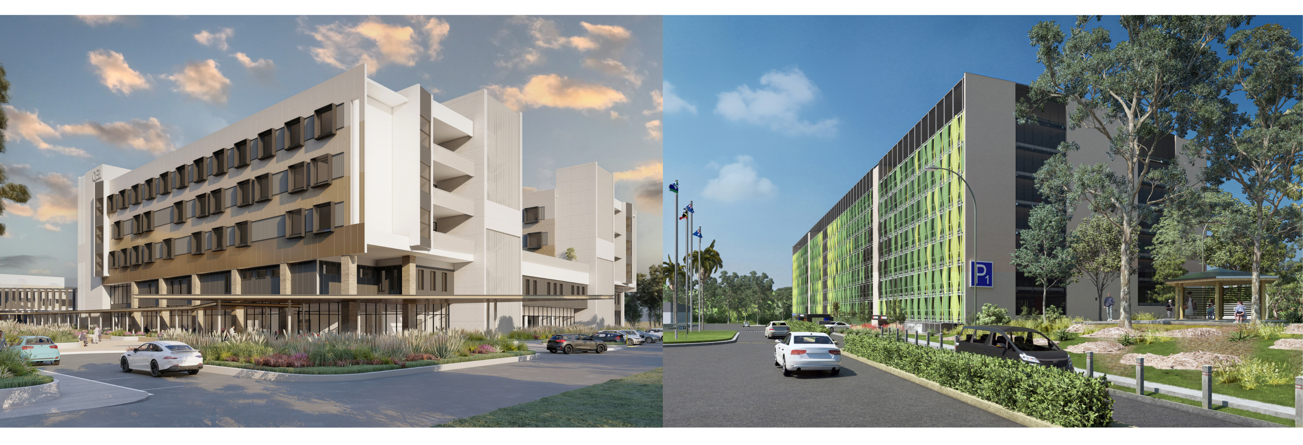

Project context – What is this about?
QEII Hospital is being transformed with a series of infrastructure projects to deliver more services and parking, closer to home for our community. The QEII Hospital Expansion will include:
- new five level Clinical Services building providing an additional 112 beds and treatment spaces
- new and expanded Intensive Care Unit (ICU)
- additional theatre capacity
- new and expanded support services
- new multi-level car park.

We are looking for artists to create artworks that reflect QEII Hospital’s local diverse communities for the new Clinical Services building spaces. Your creations may be showcased in areas such as entrances, waiting areas, meeting rooms and corridors. This is your chance to share your art with the community!

Artwork opportunities – Where will the artwork go?
The artwork will be placed in public and clinical spaces, such as:
- Entrances
- Waiting areas
- Meeting rooms
- Family lounges
- Hallways and corridors
- Internal areas of the multi-level car park.

This is a general ROI for potential artwork opportunities and will be used to develop a list of artists for consideration throughout the QEII Hospital Expansion.

Artwork format – What kind of art are we looking for?
We are looking for a range of artworks to be displayed in different formats such as:
- Large wall designs (vinyl or painted)
- Small wall decals
- Framed pictures to hang on walls
- Photography
- Textiles
- Digital artwork and animation
- Light and sound works
Some artworks may need to be in high-quality digital files.
There is an interest in innovative approaches to arts in health integration, collaboration and a focus on creating welcoming, culturally safe environments that represent the diverse communities of QEII and surrounding green areas on Country.

Selection criteria for artists – Who can apply
We are looking for artists and collectives who:
- Must show a connection to the QEII region (family, heritage, past or present residence, cultural or community ties)
- Queensland Health staff are not eligible
- Must have a current ABN or be willing to apply for one.

Artists will need to describe their connections to the QEII community in their ROI.

Relevant experience
- Show us examples of your past work. We are looking for art that fits well in a hospital.
- Must provide examples of previous work in digital format.

Availability
- Shortlisted artists must be ready to start designing from October 2026.

Artist selection process – How will we choose artists?
We will choose artists in three steps:

Step 1: Registration of Interest
  - Fill out the form and send to us.
  - You do not need to send any new ideas or designs at this stage.
  - We will review all applications and shortlist artists.

Step 2: Preliminary Design Concepts
- If shortlisted, we will ask you to create a simple design idea based on themes from the QEII community.
- You will be paid for your design work.
- We will review your designs and select the final artists for each opportunity.

Step 3: Detailed Design
If selected, you will work with our team to create the final design.
- You will be paid for your final design.
- We may ask to use your design in other places across the QEII Hospital and/or used in other media.
There may also be opportunities to acquire completed artworks such as paintings, prints and photographs later in the project.

What do you need to send us?

Biographical statement (maximum of 100 words)
- A short biography
- Tell us about yourself and your connection to the QEII area.

Your Resume (maximum of 2 pages)
Including:
- Contact details and ABN
- Experience and education
- Exhibitions
- Links to website, portfolio, social media, etc. (if available).

Artwork samples (up to 5 images)
- Show us examples of your past work.
- Please do not create any new art for this stage of application.

Registration of Interest form
- Complete the whole ROI form and questionnaires.
- If you need help on any aspect of the ROI form, please reach out to us using the contact details below.

How to send your Registration of Interest

- Email your completed ROI documents to HIQProcurement@health.qld.gov.au.
- Address your email to: Jordan Cardenas.
- Submit your Registration of Interest by 2:00pm, Tuesday 15 September
- Late or incomplete submissions may not be considered. Note, only send to the email above.
It is important to note that we are not asking artists to submit ideas or concepts during the ROI process. Successful registered artists will eventually be provided with a thorough brief which they will use to develop a concept if they are selected to progress to the next stage, which will be a Request for Offer (RFO).

Information session
For artists (or their representatives) who would like to ask questions about this opportunity and the procurement process in person, an artist information session will be held on:
Monday 7 September 2026
5pm to 6:30pm
4:45 arrival for 5pm start
The Sunny (The Eclipse Room)
SunPac Performing Arts Centre
470 McCullough St. Sunnybank, QLD 4109

Attendance is free.
RSVP to secure your spot.
Light snacks will be served.
RSVP here:
Registration – Artist Information Session – QEII Hospital Expansion Project – Artwork Opportunities
Need help or have questions? Reach out to the Tender Contact at:
HIQProcurement@health.qld.gov.au.



Call Translating and Interpreting Service (TIS National) on 131 450 for free interpreter services.

ROI Response Form 1 Supplier/Artist information
The information in the Response Forms is required for registration purposes.
As the Supplier/Artist, please respond to all questions in these Response Forms. All information in these Response Forms must be complete, accurate, up to date and not misleading.
- Please specify the legal entity type of the Supplier
- Please specify the legal name of the Supplier
- Supplier’s registered Business Name (if applicable)
- Australian Company Number (ACN)
- Australian Business Number (ABN)
- Is the Supplier registered for GST?
- State or Territory in which Business / Corporation / Individual is registered
- Name of Holding Company / Corporate Group (if applicable)
- Postal address
- Street address (registered office address of the Supplier)
- Name
- Position
- Telephone number
- Email address
- Postal address
- Street address
- Is it proposed to sub-contract any part of the Services?
- Are Notices relating to the potential Agreement to be directed to the above Contact Name and details?
- Obligations of the subcontractor?
- Is the sub-contractor classified as a small to medium enterprise (SME)*?
*Any business employing fewer than 200 people.
- Is the sub-contractor classified as an Aboriginal business and/or Torres Strait Islander business*?
*At least 50% owned by an Aboriginal person/s and/or a Torres Strait Islander person/s – Queensland Indigenous Procurement Policy.

Response Form 2 Mandatory requirements
Supplier to Note: Offers not meeting the mandatory requirements will be considered non-conforming and will not be evaluated further.
- Does your organisation warrant that it complies, and will continue to comply, with the Queensland Government Supplier Code of Conduct for the duration of any resulting contract?

Response Form 3 General Information
- Do you confirm you have the availability to commit to this project within the timeframe?
The timeframe is October 2026 to April 2027.
- Provide your Artist Statement
A short biographical statement outlining your connection to the QEII Region (no more than 100 words)

- Have you provided your CV?
A concise CV – up to 2 pages outlining previous experience, contact details including name and address, phone number, email address, ABN, education history, exhibitions, projects, website/portfolio/social media links.

- Have you attached your images?

Response Form 4 Conflict of Interest Declaration
Suppliers must supply details of any possible Conflict of Interest that exists or may arise in relation to the Registration of Interest process.  If there is nothing to declare, Suppliers must insert “Nil”. | ☐ Yes ☐ No

Supplier execution of a Registration of Interest
Acknowledgements, certification and execution by a Supplier (individual or partnership (*) (+))
I, the Supplier/authorised signatory named below, certify that in submitting the Offer:
Signed for an on behalf of:

[Insert name of Supplier]

[Insert ACN and ABN]
this [insert date] day of [insert month], [insert year]
by
[insert full name of Supplier/authorised signatory]

In the presence of
[insert full name of witness]

Note to the Supplier
(*) If a Supplier is an individual or partnership, then the above execution clause will be applicable.
(+) If the Supplier is a partnership, then all partners associated with the partnership must execute the above clause, unless authorisation has been given to an attorney.
Where an attorney executes the Offer on behalf of a Supplier, the form of execution must indicate the source of this authority, and a certified copy provided to Queensland Health.
OR
Signed for an on behalf of:

[Insert name of Supplier]

[Insert ACN and ABN]
In accordance with s.127 of the Corporations Act 2001 (Cth)
this [insert date] day of [insert month], [insert year]
by
[insert full name of Director]

[insert full name of Director/Secretary]
Where an attorney executes the Offer on behalf of a Supplier, the form of execution must indicate the source of this authority, and a certified copy provided to Queensland Health.
Privacy Statement: The Client is collecting the personal information on this Form for the purposes of offer evaluation and any subsequent contract that may arise. The information may be used in accordance with the provisions of the Invitation Documents. Any personal information included on this Offer Form may be disclosed to the Offer evaluation panel and their advisors but will not be disclosed to any other third party without the Offeror’s consent unless authorised or required by law or stipulated in the Invitation Documents. Personal information will be handled in accordance with the Information Privacy Act 2009 (Qld).
The Client is also collecting the personal information on this Form for the purposes of determining Offeror compliance with the Supplier Code of Conduct in respect of the Offer and any subsequent contract that may arise. Any personal information included on this Offer Form may be disclosed to the Queensland Government Procurement Compliance Branch within the Department of Housing and Public Works and the Tripartite Procurement Advisory Panel for compliance purposes.

